1. Checkout some background information

Statistical Significance: <https://en.wikipedia.org/wiki/Statistical_significance>

Bootstrapping: <https://en.wikipedia.org/wiki/Bootstrapping_(statistics)>

MMRE and PRED accuracy metrics

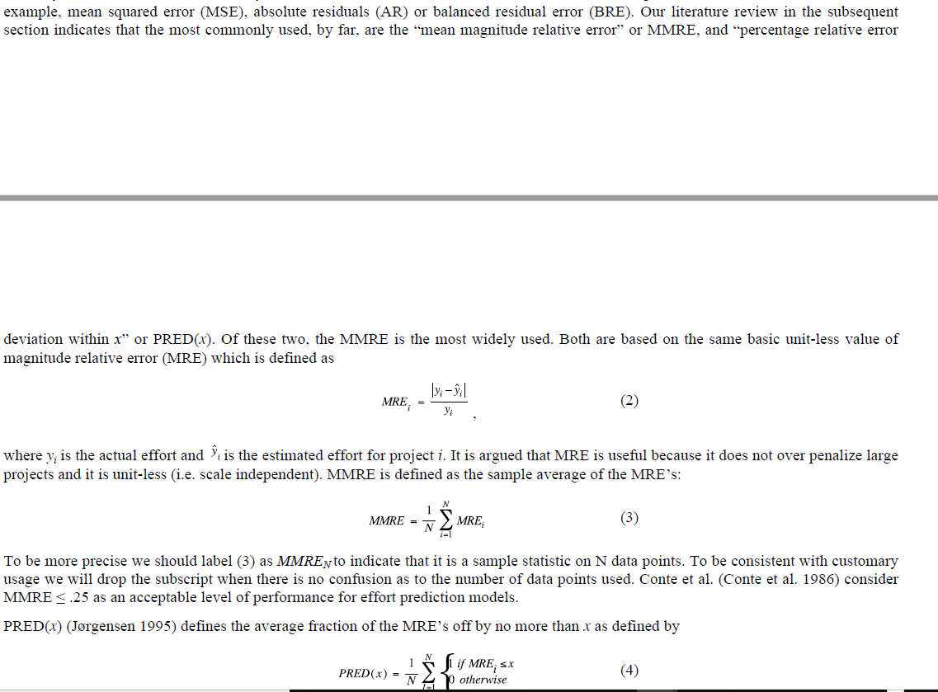

1. Bootstrapping accuracy measures

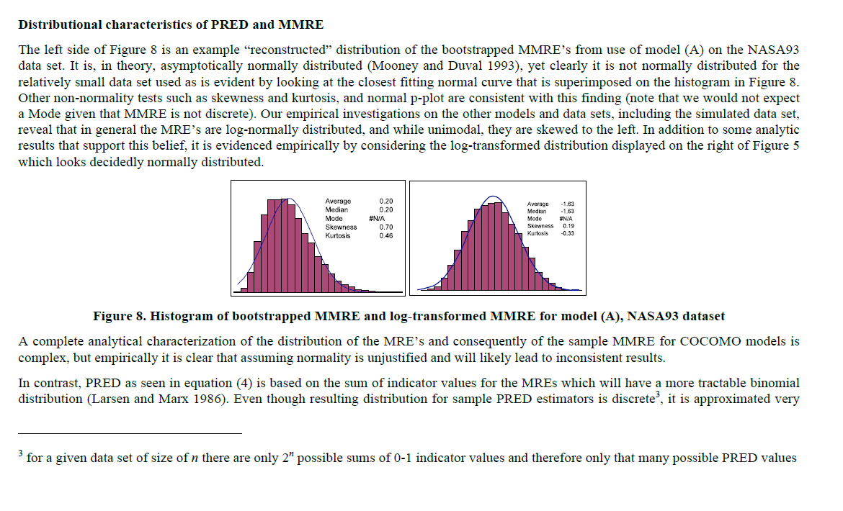

1. Think about how to integrate it into our current R script:

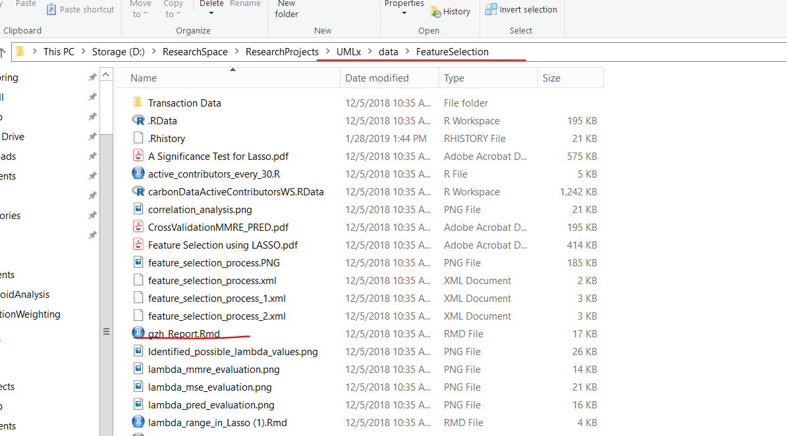

The general steps are:

1. Write a bootstrap function to sample the same size data set from original data set.
2. Use the sampled data points to run the correlation analysis, the lasso regression, and cross validation to get the error measurement (this part can be modularized). This step should be iterated through all the bootstrap samples.
3. Build the standard error and 83% confidence intervals for the accuracy measures – draw the interval plots to help visualize check the significance.
4. We can make the conclusions about the significance of accuracy assessment.